Tail dependence: GBPUSD and USDJPY
Method 19 / daily log returns / alpha=0.05 / Alpari D1 full available history

Study setup
Logical pair: GBPUSD , USDJPY
Broker symbols: GBPUSD_i , USDJPY_i
Snapshot: 2026-11-03_majors_alpari_D1
Timeframe: D1
Matched return window: 1999-01-05 to 2026-11-02 (UTC bar dates)
Matched return count n: 7200
Dropped unfinished last bar dated 2026-11-03 UTC after a tick-volume check against the prior complete day.
Uniforms: ranks/(n+1); alpha=0.05
Complete matched rows (Excel): GBPUSD-USDJPY_Tail_D1.xlsx
Complete matched rows (HTML table): GBPUSD-USDJPY_Tail_D1_data.html

Method carried forward
Tail dependence counts how often both legs sit in an extreme uniform tail together. Matched daily log returns of close, ln(close_t / close_t-1), become u_i = rank(x_i)/(n+1) and v_i = rank(y_i)/(n+1). At alpha=0.05, lower L_hat = (# u<=alpha and v<=alpha) / (# conditioning leg <= alpha); upper uses >= 1-alpha. Both conditioning directions are reported with numerator and denominator counts. Quotes are not inverted. L_hat(0.05) is a finite-sample frequency, not the asymptotic lambda. Same-sample Pearson r is a side check. This is not causation and not a trading signal.

Results
tail | cond | L_hat | num | denom
lower | USDJPY | 0.080556 | 29 | 360
lower | GBPUSD | 0.080556 | 29 | 360
upper | USDJPY | 0.066667 | 24 | 360
upper | GBPUSD | 0.066667 | 24 | 360
Pearson r on returns: -0.198556

Conclusion
Over 7200 matched daily rows for GBPUSD and USDJPY at alpha=0.05, lower L_hat conditioning on USDJPY is 0.0806 (29/360); conditioning on GBPUSD is 0.0806. Upper L_hat conditioning on USDJPY is 0.0667; on GBPUSD is 0.0667. Pearson r = -0.1986. These are finite-sample frequencies, not asymptotic lambda and not a trading signal.

Charts
Daily closes

Daily log returns

Uniforms with alpha lines
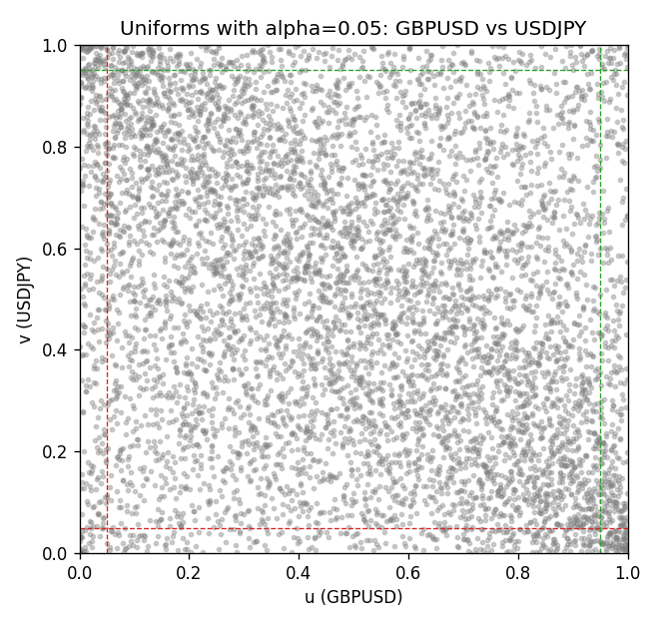

Data report
Every matched row is stored in the sibling Excel workbook named GBPUSD-USDJPY_Tail_D1.xlsx, including u and v. Embedding all rows as a Word table is impractical; this file holds column summaries and the first and last 15 matched rows.
Columns: time, GBPUSD_open, USDJPY_open, GBPUSD_high, USDJPY_high, GBPUSD_low, USDJPY_low, GBPUSD_close, USDJPY_close, GBPUSD_tick_volume, USDJPY_tick_volume, GBPUSD_spread, USDJPY_spread, GBPUSD_real_volume, USDJPY_real_volume, GBPUSD_log_return, USDJPY_log_return, u, v
Column summaries (matched calculation rows)
column | count | mean | std | min | 25% | 50% | 75% | max
GBPUSD_open | 7200 | 1.5159933 | 0.21821503 | 1.06854 | 1.3249725 | 1.51133 | 1.63163 | 2.1066
USDJPY_open | 7200 | 113.81122 | 19.205564 | 75.693 | 104.42925 | 110.991 | 120.69125 | 163.824
GBPUSD_high | 7200 | 1.5222906 | 0.21878569 | 1.08366 | 1.329785 | 1.518035 | 1.638315 | 2.1161
USDJPY_high | 7200 | 114.30876 | 19.267108 | 76.001 | 104.8815 | 111.4435 | 121.26 | 163.978
GBPUSD_low | 7200 | 1.5096683 | 0.2174426 | 1.03518 | 1.319445 | 1.50319 | 1.6243 | 2.0983
USDJPY_low | 7200 | 113.28793 | 19.133561 | 75.402 | 103.89 | 110.5305 | 120.17 | 163.628
GBPUSD_close | 7200 | 1.5160611 | 0.21817876 | 1.06879 | 1.3250775 | 1.511235 | 1.63193 | 2.1065
USDJPY_close | 7200 | 113.82409 | 19.220954 | 75.811 | 104.42 | 111.028 | 120.6855 | 163.851
GBPUSD_tick_volume | 7200 | 94838.03 | 153554.65 | 62 | 10001.75 | 52905.5 | 91812.25 | 1273370
USDJPY_tick_volume | 7200 | 106136.9 | 179308.31 | 149 | 9925 | 53095 | 92761 | 1803508
GBPUSD_spread | 7200 | 26.967917 | 19.192953 | 0 | 11 | 20 | 50 | 50
USDJPY_spread | 7200 | 20.325556 | 17.633971 | 0 | 6 | 11 | 30 | 50
GBPUSD_real_volume | 7200 | 3.5565837e+09 | 8.4444068e+10 | 0 | 0 | 0 | 0 | 2.4038164e+12
USDJPY_real_volume | 7200 | 3.470121e+10 | 1.6077679e+11 | 0 | 0 | 0 | 0 | 3.8834203e+12
GBPUSD_log_return | 7200 | -2.396e-05 | 0.00564572 | -0.08388241 | -0.0031301 | 3.232e-05 | 0.00317911 | 0.03112653
USDJPY_log_return | 7200 | 4.769e-05 | 0.00620489 | -0.03908203 | -0.00320192 | 0.00011421 | 0.00340709 | 0.05184024
u | 7200 | 0.5 | 0.28865509 | 0.00013887 | 0.25006943 | 0.5 | 0.74993057 | 0.99986113
v | 7200 | 0.5 | 0.28865508 | 0.00013887 | 0.25006943 | 0.5 | 0.74993057 | 0.99986113
First 15 matched rows (selected columns)
time | GBPUSD_log_return | USDJPY_log_return | u | v
1999-01-05 | -0.0028966287 | -0.00017868311 | 0.26621303 | 0.47132343
1999-01-06 | -0.00060452184 | 0.0075660159 | 0.4417442 | 0.91167893
1999-01-07 | -0.002118709 | -0.012851583 | 0.32106652 | 0.023191223
1999-01-08 | -0.0058954193 | -0.0047719894 | 0.11803916 | 0.1685877
1999-01-11 | -0.0056851331 | -0.016195423 | 0.12498264 | 0.013331482
1999-01-12 | 0.0022657001 | 0.032310364 | 0.68879322 | 0.99958339
1999-01-13 | 0.0091330396 | 0.0081373171 | 0.95472851 | 0.92501042
1999-01-14 | 0.0019376331 | 0 | 0.66185252 | 0.48750174
1999-01-15 | -0.0017558204 | 0.0055343401 | 0.3485627 | 0.85168727
1999-01-18 | 0.0012112405 | 8.7600193e-05 | 0.60380503 | 0.49743091
1999-01-19 | 0.0018745281 | -0.0056219403 | 0.65602 | 0.13956395
1999-01-20 | -0.0049053846 | -0.0053879917 | 0.15636717 | 0.1466463
1999-01-21 | 0.0031518998 | 0.0084664056 | 0.7478128 | 0.92959311
1999-01-22 | 0.0024781662 | 0.0060412564 | 0.70393001 | 0.86932371
1999-01-25 | 0.0012066366 | -0.0073594164 | 0.60338842 | 0.092348285
Last 15 matched rows (selected columns)
time | GBPUSD_log_return | USDJPY_log_return | u | v
2026-10-13 | 0.0036434319 | -0.0018932826 | 0.77739203 | 0.32801
2026-10-14 | -0.0049164679 | 7.5800166e-05 | 0.15581169 | 0.49562561
2026-10-15 | 0.0065976411 | -0.0018524319 | 0.90334676 | 0.33092626
2026-10-16 | 0.0037592051 | -0.00037976126 | 0.78419664 | 0.45021525
2026-10-19 | -0.0017500314 | 0.0034946841 | 0.34967366 | 0.75503402
2026-10-20 | 0.0055923442 | -0.0022546642 | 0.87029579 | 0.30398556
2026-10-21 | 0.0012476328 | -0.00032883504 | 0.60658242 | 0.45618664
2026-10-22 | 0.00022396082 | -0.0085942669 | 0.51826135 | 0.066796278
2026-10-23 | -0.0021146949 | 0.00035080446 | 0.321622 | 0.52187196
2026-10-26 | -0.0024340661 | 0.0041238746 | 0.29718095 | 0.79155673
2026-10-27 | -0.0023648393 | 0.0027651658 | 0.30231912 | 0.71170671
2026-10-28 | 0.0015771808 | -0.00095679538 | 0.63338425 | 0.39841689
2026-10-29 | 0.0035881935 | -0.00038043789 | 0.77517012 | 0.45007638
2026-10-30 | 0.0013450605 | -0.0010596481 | 0.61449799 | 0.39189002
2026-11-02 | 0.0010971256 | 0.0026438521 | 0.59436189 | 0.7035134

